**NỘI DUNG BÀI HỌC MÔN TIẾNG ANH 6**

**TUẦN 14 (Từ 5/12 đến 19/12/2022)**

**UNIT 5 – AROUND TOWN**

**LESSON 1**

**I. NEW WORDS**

1. large (adj) /lɑːdʒ/ : to, lớn

2. extra large (adj) /ˈekstrə lɑːdʒ / : cực lớn

3. jeans (n) /dʒiːnz/ : quần jean

4. changing room (n) /’tʃeɪndʒɪŋ ruːm/ : phòng thay đồ

5. medium (adj) /ˈmiːdiəm/ : trung bình

6. sweater (n) /ˈswetə(r)/ : áo len

7. customer (n) /ˈkʌstəmər/ : khách hàng

8. Sales assistant (n) /seɪlz əˈsɪstənt/ / : trợ lí bán hàng

9. sizes (n) /saɪziz/ : kích cỡ, kích thước

10. clothes (n) /kləʊz/ : quần áo

**II.GRAMMAR**

1. **Demonstratives: this/ that / these / those**

**( đại từ chỉ định this / that / these / those )**

**We use “this / that / these / those” to show which things we are talking about**

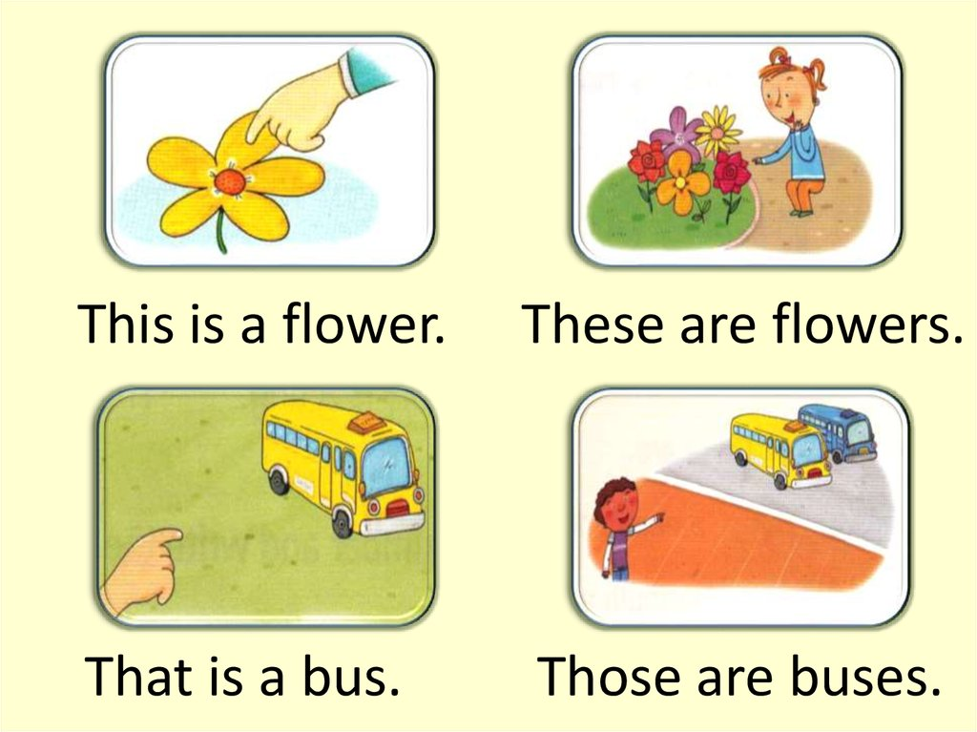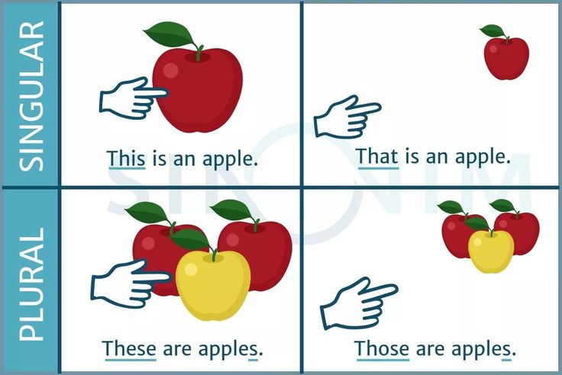**( Chúng ta dùng “this / that / these / those” để chỉ ra những thứ mà chúng ta đang nói đến)**

**This / that ( Đây / Kia ) :** for singular nouns (dùng cho danh từ số ít )

**These / those** **( Những cái này / Những cái kia )** : for plural nouns (dùng cho danh từ số nhiều)

**This / these ( cái này/ những cái này) :** for thing/ things close to the speaker(dùng chỉ vật/những vật ở gần người nói)

**That / those (Kia/ những cái kia ) :** for thing/ things further away (dùng chỉ những vật ở xa người nói)

**B. How much is …? / How much are …?: Bao nhiêu …?**

|  |
| --- |
| **How much is this / that + singular noun?** |

**Ex: How much is this T-shirt ?**

**How much is that dress?**

|  |
| --- |
| **How much are these / those + plural nouns ?** |

**Ex: How much are these shoes ?**

**How much are those socks ?**

1. **Object pronoun ( đại từ ở vị trí tân ngữ ): it / them**

**We use “it / them” after a verb or a preposition. ( Chúng ta dùng “it / them” sau 1 động từ hoặc 1 giới từ)**

**We use “it” for singular noun and “them” for plural noun.( Chúng ta dùng “it” cho danh từ số ít và “them” cho danh từ số nhiều.)**

**Ex: I like this dress. Do you like it, too ?**

**I like these shoes. Can I try them on?**

**Do you see my T-shirt? I am looking for it.**

**Do you see my shoes? I am looking for them.**

**III.PRACTICE**

**1. Fill in the blanks with the correct form of the words.**

1. ________ is a dress. (These)

2. _______ sweaters are pink. (This)

3. How much is ________ blue shirt ? (those)

4. How much are _________ red shoes ? (this)

5. ________ pants are cheap. (That)

6. I like _____ brown dress. (These)

7. My brother likes ________ green books. (this)

8. He doesn’t like _________red sweater. (those)

**2. Choose the word or phrase (A, B, C or D) that best fits the space in each sentence.**

1. This T-shirt is very big. It’s an ______________size.

A. medium B. extra large C. small D. large

2. Do you have this dress in a ____________size. This medium one is too small.

A. small B. extra large C. delicious D. medium

3. Do you have these ____________ in dark blue? Can I try them on.

A. sweater B. T-shirt C. dress D. jeans

4. A ________________works in a store.

A. teacher B customer C. sales assistant D. students

5. A ________________wants a medium pink dress.

A. customer B. dress C. sweater D. jacket

6. This pink __________ is so nice.

A. sweater B. clothes C. T-shirts D. shirts

7. That green dress is too big. This one is too small. Do you have it in a __________ size?

A. big B. medium C. small D. extra large

8. Can I try this sweater on? – Yes, the ______________________is over there.

A. yard B. gym C. changing room D. balcony

9. How much is this _________ ?

A. T-shirts B. sweater C. shoes D. shirts

10. Jeans, sweater, dress and shirt are _____________.

A. sales assistant B. changing room C. customer D. clothes

**3. Choose the word (A, B, C or D) that best fits the space in the following passage.**

Alice likes shopping. She often goes (11) _____with her mom on the weekend. She (12) ____at the clothing store now. She wants some new clothes for the coming winter. There are many colors and sizes. She needs a sweater, a hat and pants (13) ___ blue because she likes blue (14) _____. She is choosing a shirt for her mom. The shirt is 20 dollars. She feels (15) ______ when she goes out.

11. A. sports center B. restaurant C. to the mall D. apartment

12. A. am B. is C.are D. be

13. A. to B. on C. at D. in

14. A. color B. size C. style D. changing room

15. A. ugly B. unhappy C. happy D. sad

**4. Rewrite each of the following sentences in another way so that it means almost the same as the sentence printed before it.**

16.Does she have the shoes in black?

🡪Does she

17. There is a changing room over there.

🡪The changing room

18. Does your store have a pink dress?

🡪 Is there ?

19. The sweater’s price is 45$.

🡪 The sweater

20. These shirts are small.

🡪These are